User Guide

Leaf Analysis

Mobile and ubiquitous Computing

msc computer science

Daniel Elstob

14011862@hope.ac.uk

Table of Contents

Figures 2

Introduction 3

Goals 3

Setup 3

Basic Tutorial 3

Image File Preparation 3

Program Navigation 4

Edge Extraction 4

Open Image 4

Find Edges 5

Choose Edges 6

Providing Information About Image 7

Rendering an Image 7

Creating/Building a Database 8

Create New Database 8

Update Database 8

Save Database 9

Open Existing Database 10

Comparing Edges 10

Ordering of Known Edges 11

Saving Compare Results 12

Save Information 13

Save Database 13

Save Rendered Edge 13

# Figures

Figure 1 - Good Image vs. Bad Image 3

Figure 2 - Program Start-up 4

Figure 3 - Open Image Figure 4 -Selecting a suitable image 4

Figure 5 - Image Viewer 5

Figure 6 - Find Edges Figure 7 – Edge Results and Leaf Information 6

Figure 8 - Choosing Edges 6

Figure 9 - Leaf Information Example 7

Figure 10 - Rendered Maple Leaf Edge 7

Figure 11 - Create New Database 8

Figure 12 - New Database Message 8

Figure 13 - Update Database Figure 14 - Update Database Message 9

Figure 15 - Save Database Figure 16 - Save Database Window 9

Figure 17 - Alert Message 9

Figure 18 - Save Confirmation 10

Figure 19 - Open Existing Database Figure 20 - Opening Confirmation 10

Figure 21 – Error Messages 10

Figure 22 - Compare Results Window 11

Figure 23 - Species List Figure 24 - Selecting Edge 12

Figure 25 - Save Comparison Confirmation Message 12

Figure 26 - Comparison Saved Image 13

Figure 27 - Save Database 13

Figure 28 - Save Rendered Edge 13

# Introduction

This is a user guide for the program ‘Leaf Analysis’ which covers both a basic tutorial and in depth tutorials for all the features that can be used.

## Goals

The initial goal of this program was to allow the user to identify trees or flowers from images of their leaves. The program analyses the image of a leaf on a white background, extracts the leaf edge, and compares the edge against a database of edges. When the program compares the edge, it sorts the species of leaves in the database by similarity with the most similar appearing at the top of the drop down list.

## Setup

This section will cover the development tools used to create the program. For viewing the source code the chosen IDE was Netbeans 7.0 and a common library issue with this program is the javaws.jar which is included within the file ‘LeafAnalysis\dist\lib\ javaws.jar’ should the IDE ask for it. The program will work with all operating systems that support Java 6 and higher. Alternatively you can open the executable file ‘LeafAnalysis\dist\LeafAnalysis.exe’.

# Basic Tutorial

1. Start Program using the LeafAnalysis.exe.
2. Open database ‘LeafAnalysis.odb’. It may take a while to load; a beep will sound when it has opened.
3. Open an image. Make sure you open an image with leaves on a white background.
4. Analyse the image with ‘Find Edges’.
5. Select edges that have been correctly found in the image.
6. ‘Compare’ to identify your leaf of interest.
7. Examine the superimposed leaf edges to assess the similarity of the leaf shape. The program orders species by how similar they are, smaller percentage being more similar.
8. ‘Render Edge’ will allow you to see the leaf edge more clearly.

# Image File Preparation

In order to find edges the image used should have the leaf of interest place on a white background, with the top of the object (i.e. the apex of the leaf) towards the top. The whiter the background the better, Figure 1 shows a good and bad example respectively.

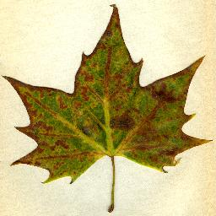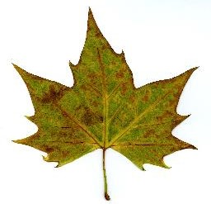

Figure 1 - Good Image vs. Bad Image

# Program Navigation

This section will explain the menus and feature the program has to offer. When the program is first run it will look like Figure 2.

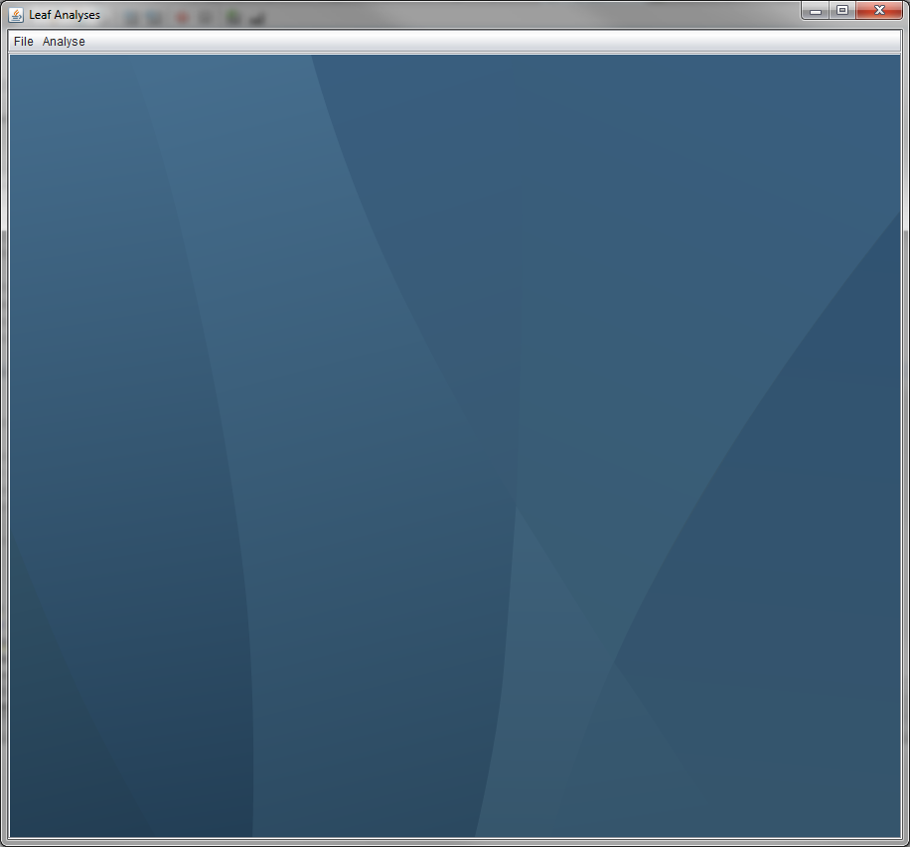

Figure 2 - Program Start-up

# Edge Extraction

This section describes how to find and extract edges from images of leaves.

## Open Image

Figure 3 shows how to navigate the menu to open an image. A window will appear (Figure 4) and allow the user to select a suitable image which will then be loaded into the ‘Image Viewer’ (Figure 5).

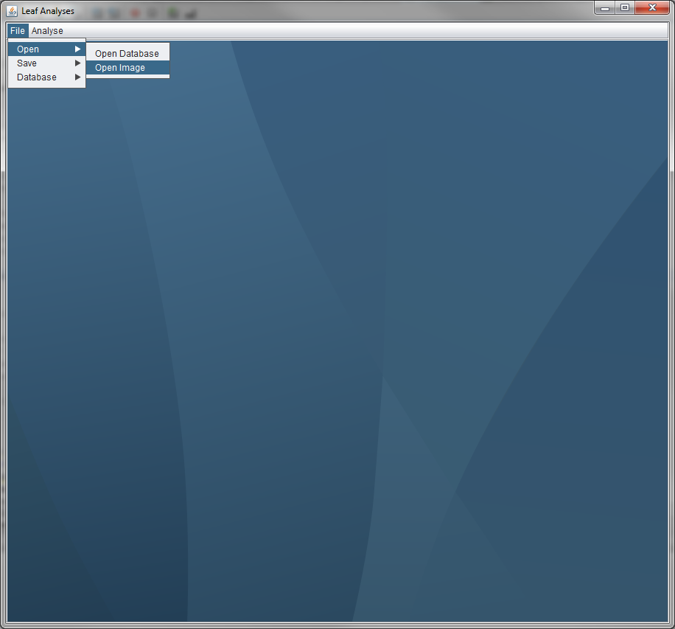 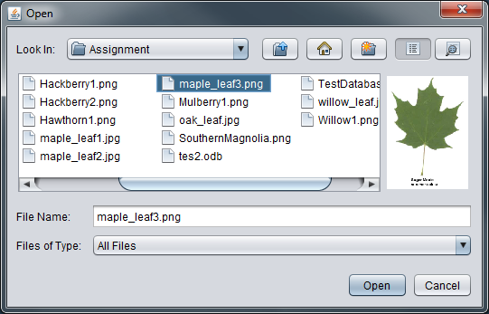

Figure 3 - Open Image Figure 4 -Selecting a suitable image

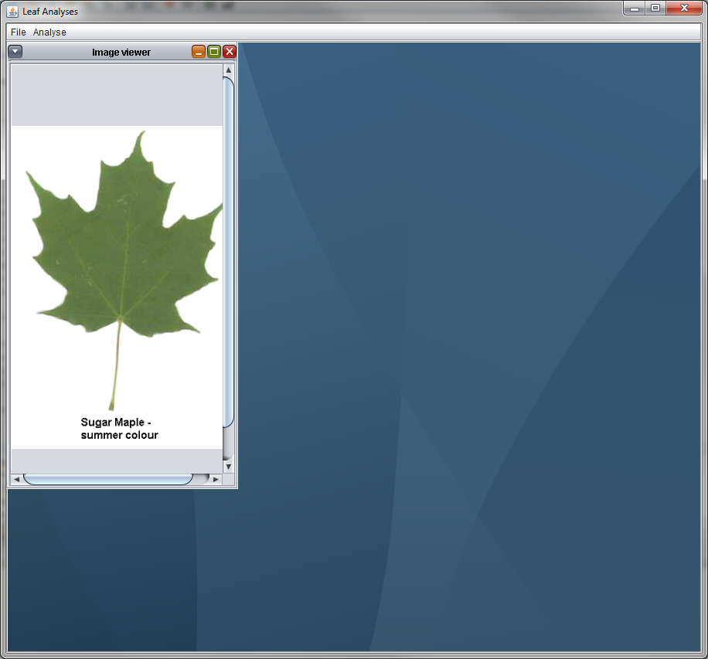

Figure 5 - Image Viewer

## Find Edges

After opening an image, navigation to the ‘Find Edges’ sub-menu (Figure 6), after selecting this there may be a short delay as the program analyses the image for any edge, the pixel area and the centroid size. Once analyse the results will be presented in the ‘Edges Results’ window (Figure 7) as well as the ‘Leaf Information’ window.

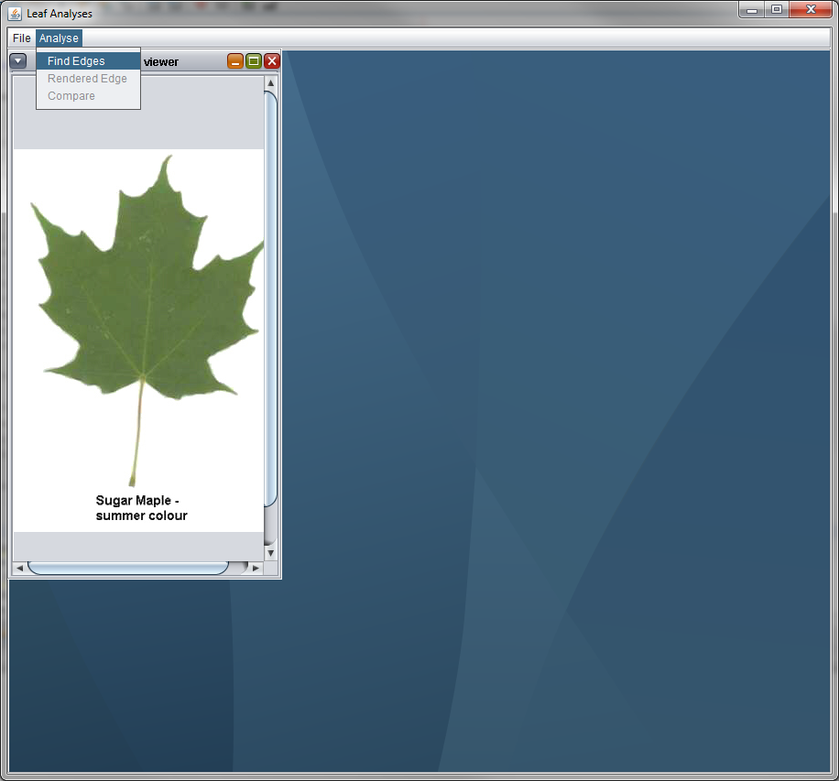 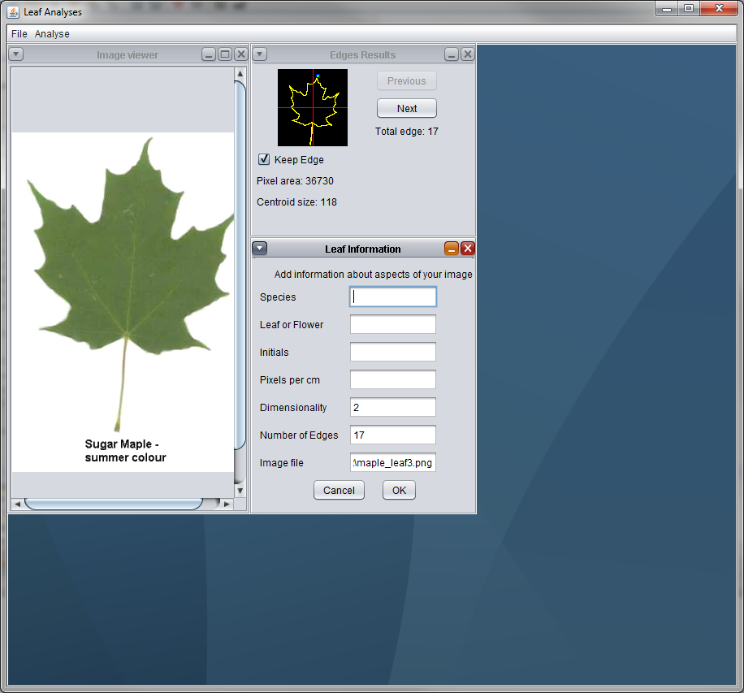

Figure 6 - Find Edges Figure 7 – Edge Results and Leaf Information

## Choose Edges

At this stage you may have numerous different results (Figure 8). In the ‘Edges Results’ window use the ‘Next’ and ‘Previous’ buttons to go through the edges found and if there is an edge that the user does not desire or is an inaccurate representation of the leaf then simply uncheck the ‘Keep Edge’ checkbox. This will discard that edge from further analysis. The ideal edge should resemble the original leaf shape and a blue square should be present at the apex of the leaf. If the square is not present deselect that edge as it will interfere with future analysis.

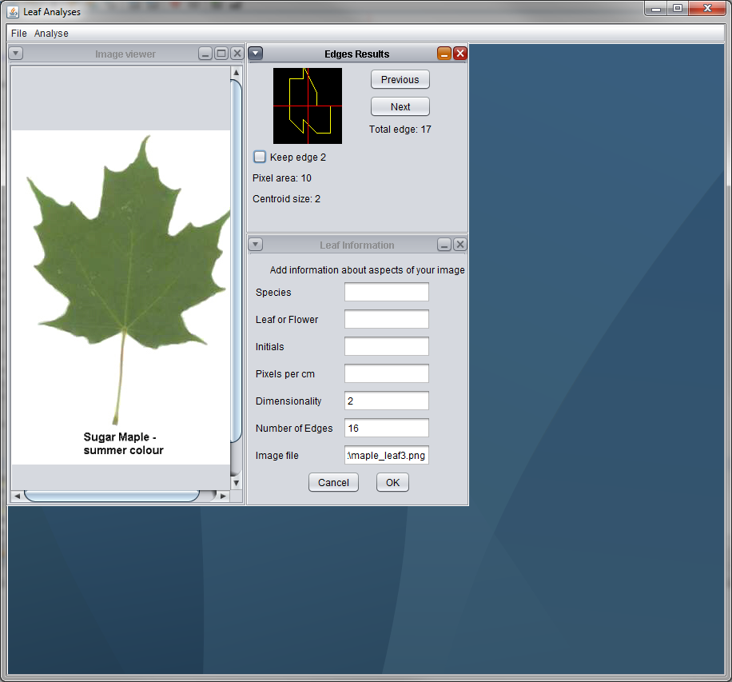

Figure 8 - Choosing Edges

## Providing Information About Image

The other menu that appeared after analysing the image is the ‘Leaf Information’ window that asks the user to provide information about the image; the ‘Species’ of the leaf, as this was aimed for flower as well as tree leaves an option about whether it is a ‘Leaf or Flower’, the user’s ‘Initials’ as a signature and the ‘Pixels per cm’ which for the majority of the images within the database is 100. The last three textboxes will be automatically calculated and filled in. Figure 9 shows an example of a filled in form. This information will be stored, alongside the edges, when saved to a database.

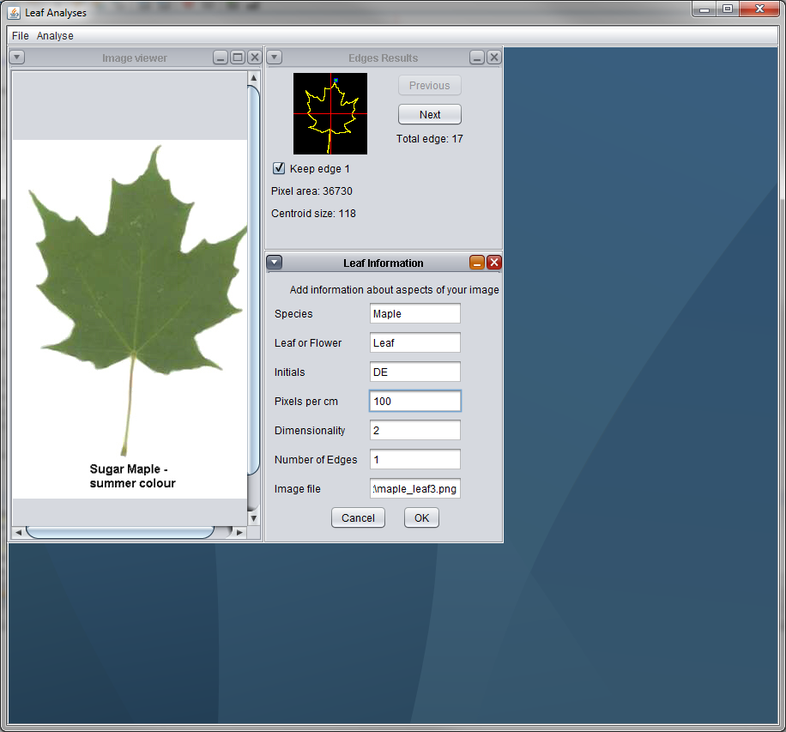

Figure 9 - Leaf Information Example

# Rendering an Image

After the analyse stage of the image has been successfully done, the user is able to render the edge into a larger and clearer window that the ‘Edges Results’ window. Figure 10 shows what a rendered edge of the maple leaf would look like.

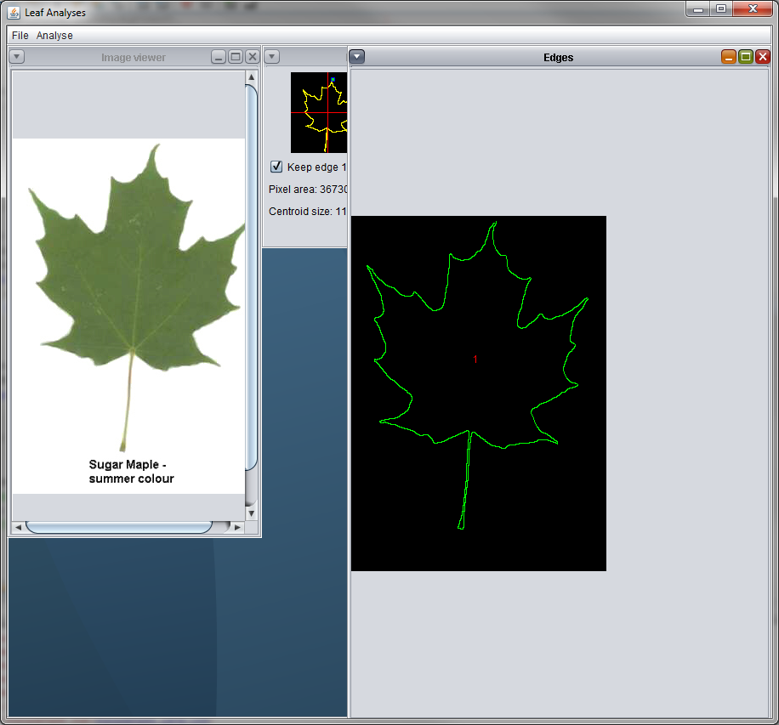

Figure 10 - Rendered Maple Leaf Edge

# Creating/Building a Database

This section will explain how to create a new database or build on an existing one.

## Create New Database

To create a new database the user must first have already selected well defined edges from an image and then have provided information about the image. From this point a database can be created that contain these edges (Figure 11).

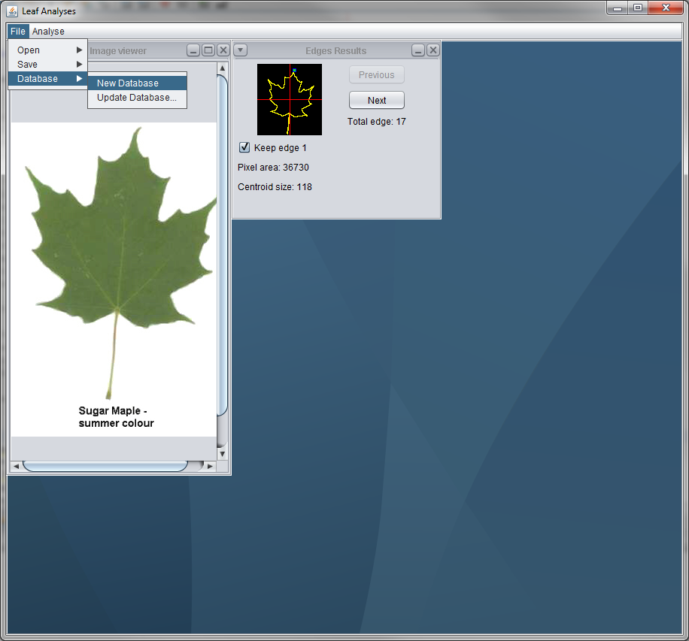

Figure 11 - Create New Database

Any database that was currently in the program’s memory will be overwritten by the newly created database and will show a message (Figure 12). It will automatically store the current edge information within the database.

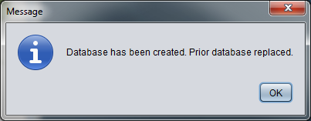

Figure 12 - New Database Message

## Update Database

If the users wishes to add to a database already in the program’s memory, first select well defined edges from an image and then provide information about the image. From this point the database can be updated (Figure 13) and if successful will present a message (Figure 14).

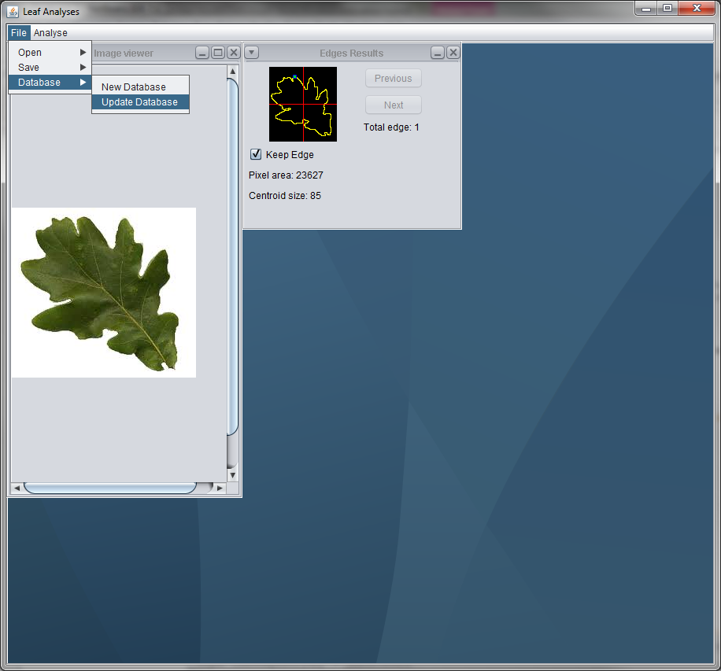 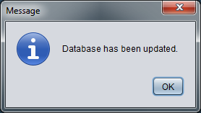

Figure 13 - Update Database Figure 14 - Update Database Message

## Save Database

After creating or updating a database, in order to keep the new edges and information the database must be saved (Figure 15) and the database file type uses the open database format ‘.odb’. If this is the first save after creating the database a window will appear (Figure 16) to designate where the database will be save to, if it isn’t then select the database to overwrite.

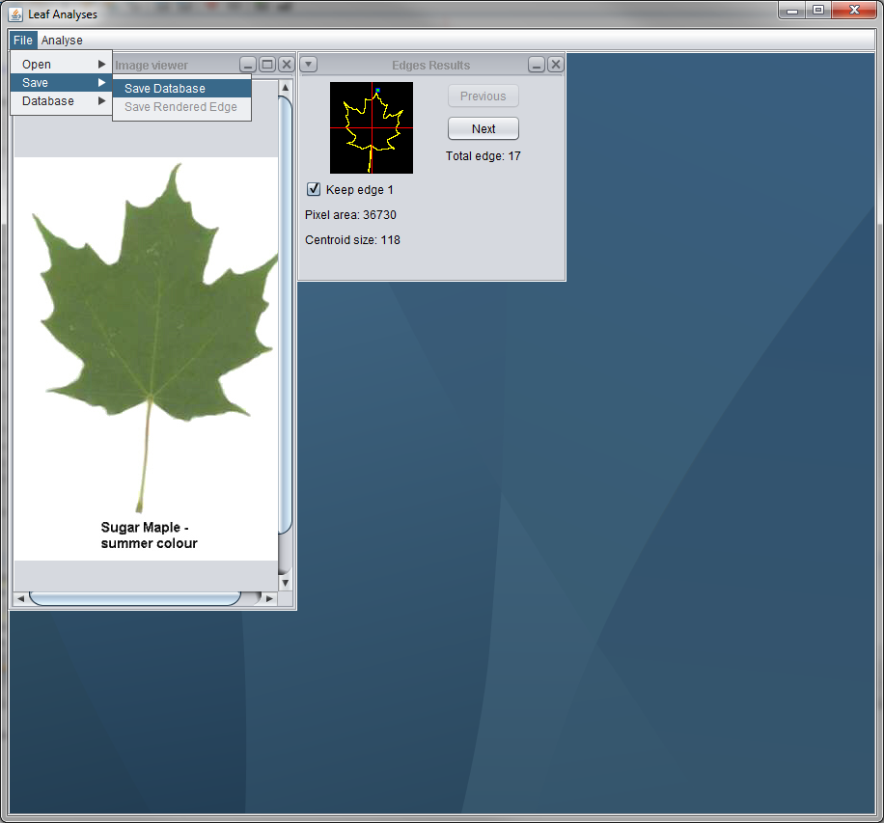 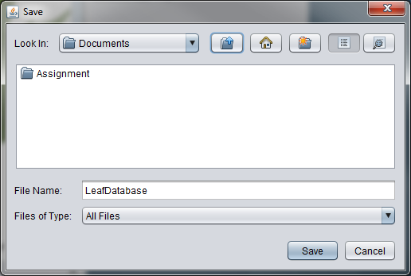

Figure 15 - Save Database Figure 16 - Save Database Window

Once a suitable location has been chosen it may take a few moments of processing to fully save. To help with this phase an alert message (Figure 17) will popup and a ‘Beep’ sound will be produced on completion of save along with a message confirmation the save location (Figure 18).

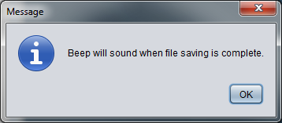

Figure 17 - Alert Message

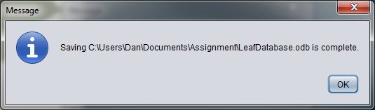

Figure 18 - Save Confirmation

## Open Existing Database

After a database has been created and saved, it may be read back into the computer’s memory (Figure 19). Alternatively a sample database has been provided called ‘LeafDatabase.odb’ which can be used to update or compare against. If the database is suitable a confirmation message will appear and say how many edges are stored in the database.

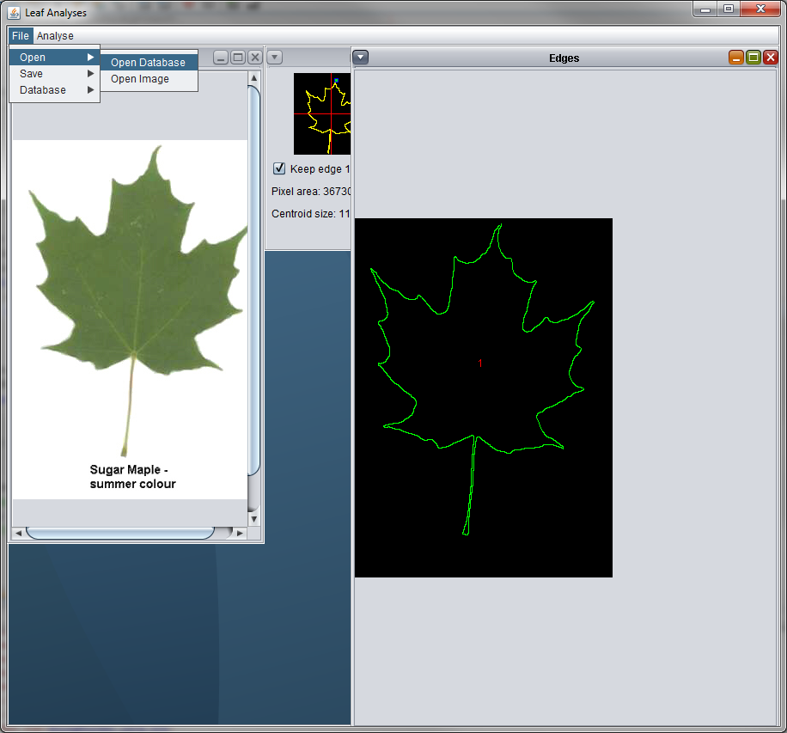 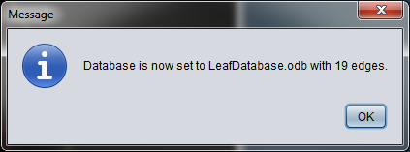

Figure 19 - Open Existing Database Figure 20 - Opening Confirmation

If the database is unsuitable either due to being the wrong file format or due to being edited manually error messages will appear saying that the chosen database cannot be used (Figure 21).

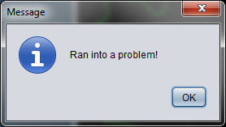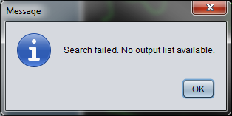

Figure 21 – Error Messages

# Comparing Edges

After opening a database and having selected the edges desired for comparison with those in the database select ‘Compare’ from the ‘Analyse’ menu. After the search process is complete a window ‘Compare Results’ will appear (Figure 22). The different items in this window are explained below.

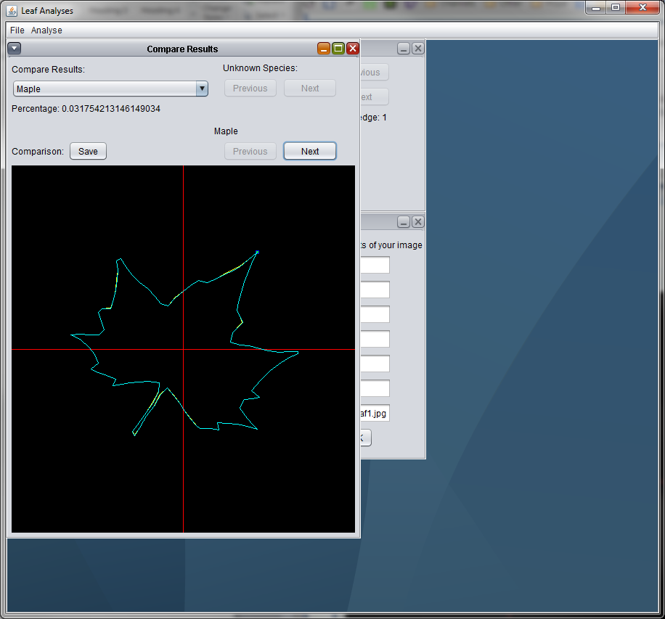

Figure 22 - Compare Results Window

## Ordering of Known Edges

The ‘Compare Results’ window will list all the know species and their edges from the database ordered by how well they match the edge chosen (Figure 23). A user is able to select any of the species to display its edges (blue) over the chosen edge (yellow), by selecting the ‘Next’ and ‘Previous’ buttons underneath the species name(Figure 24). The buttons underneath ‘Unknown Species’ would be used if you had multiple edges being compare (i.e. you kept more than one edge from ‘Edge Results’.

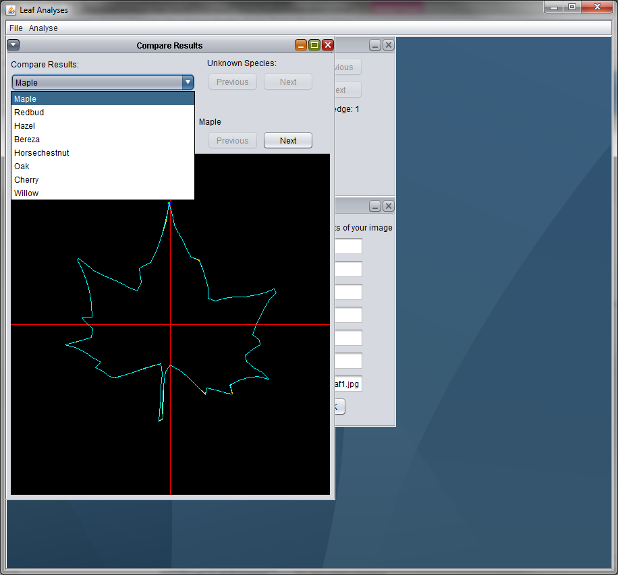 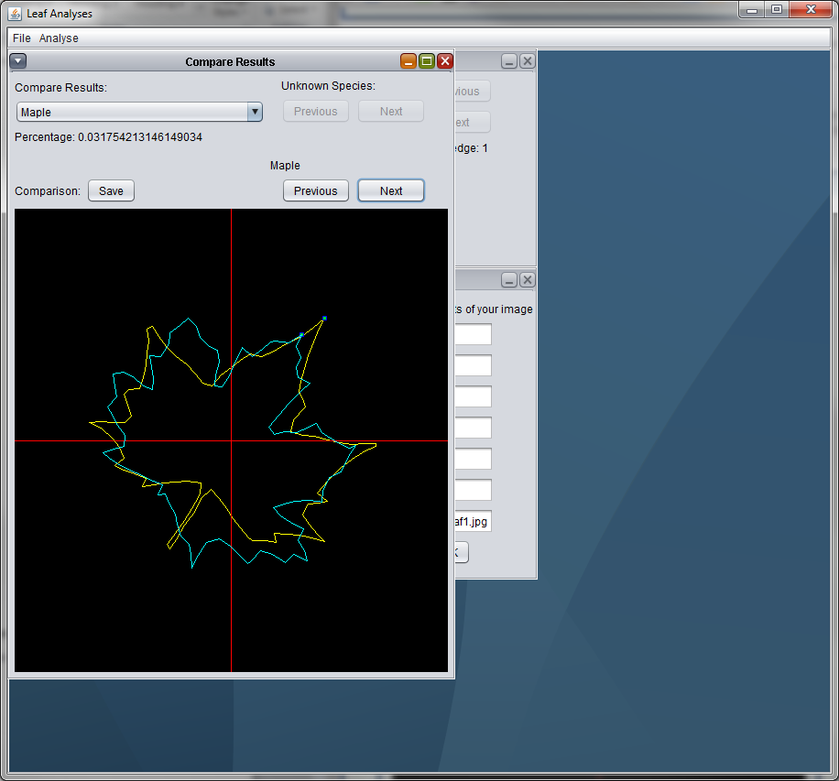

Figure 23 - Species List Figure 24 - Selecting Edge

## Saving Compare Results

Any of the superimposed edges in the ‘Compare Results’ window can be saved by pressing the ‘Save’ button. After choosing a suitable location a confirmation message will appear (Figure 25). The resulting image is the superimposed edges (Figure 26).

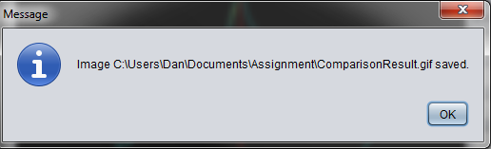

Figure 25 - Save Comparison Confirmation Message

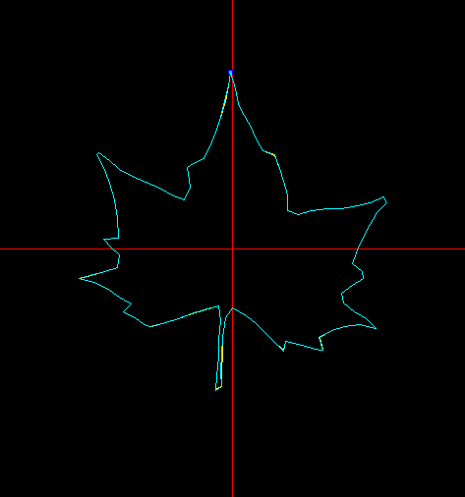

Figure 26 - Comparison Saved Image

# Save Information

This section will describe how to save information, all of which can be accessed through the ‘File’ Menu.

## Save Database

First, create, update or open an existing database, then save database (Figure 27).

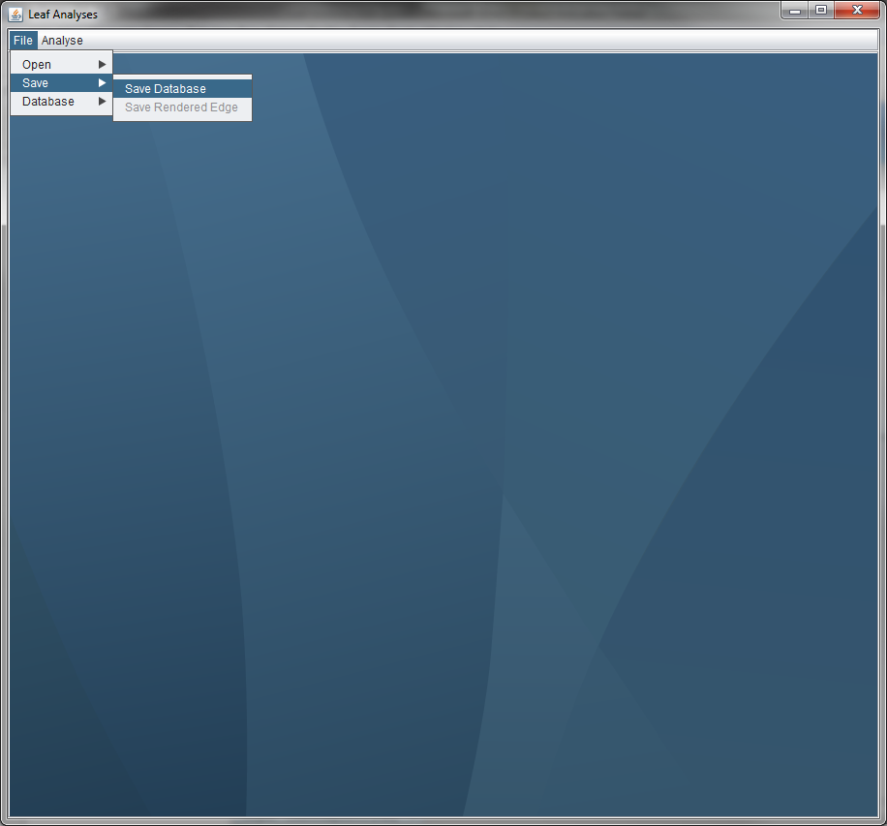

Figure 27 - Save Database

## Save Rendered Edge

First, render an image that has been analysed, then save the rendered image (Figure 28).

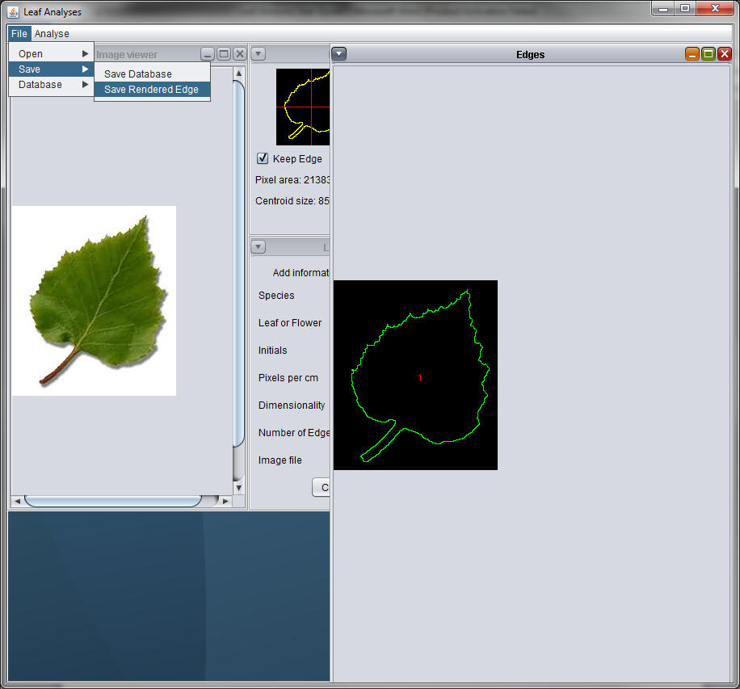

Figure 28 - Save Rendered Edge